GROCERY INVENTORY SYSTEM
@CREATIVITY THINK (9483175986/7019689991)

ABSTRACT:
The Grocery Inventory System is a web application designed to streamline inventory management for grocery stores, retail outlets, and supply chain operations. Users can manage item stocks, add or remove quantities, and receive reorder alerts, while administrators manage suppliers, track usage analytics, and oversee the inventory through a centralized dashboard. Built using Django, Django Rest Framework, React, chart.js, and axios, the system provides real-time updates, analytics visualizations, and alerts to optimize stock control, reduce shortages, and enhance operational efficiency for businesses..

INTRODUCTION OF THE PROJECT:
Inventory management is critical for grocery stores and retail outlets to maintain optimal stock levels, prevent shortages, and streamline supply chains. The Grocery Inventory System enables users to monitor stock, set reorder alerts, and view dashboard analytics, while administrators manage suppliers, track statistics, and analyze inventory trends. The system leverages Django and DRF for backend logic, React for frontend interaction, and chart.js for data visualization, providing an intuitive interface that simplifies day-to-day inventory operations and enhances decision-making..

PROJECT OBJECTIVES:

• Enable real-time stock tracking and management
• Allow users to add or remove inventory items
• Generate reorder alerts for low-stock items
• Track supplier details and item sources
• Provide visual analytics and usage statistics
• Enable administrators to manage suppliers efficiently
• Centralize inventory control through dashboards
• Improve decision-making for supply chain optimization

PROBLEM OF THE STATEMENT:
Traditional inventory systems rely on manual tracking, which often leads to stock discrepancies, overstocking, or shortages. Lack of real-time analytics and alerts can delay replenishment, affecting business efficiency. The Grocery Inventory System addresses these issues by providing automated stock monitoring, reorder notifications, supplier management, and analytics dashboards, allowing both users and administrators to make informed inventory decisions in real time..

MOTIVATION OF THE PROJECT:
• Ensure accurate real-time stock tracking
• Prevent stock shortages and overstocking
• Provide timely alerts for reordering items
• Facilitate supplier management for smooth operations
• Enhance decision-making with analytics dashboards

BLOCK DAIGRAM OF PROJECT:

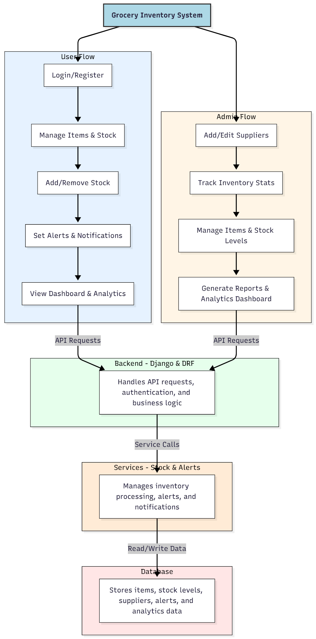

WORKING OF THE PROJECT:
Users log in to the system to manage grocery items, add or remove stock quantities, and set alerts for low-stock items. They can view stock levels and analytics via a dashboard for quick insights. Administrators add and edit supplier information, track inventory statistics, manage items, and generate comprehensive reports through dashboards. The backend handles API requests, authentication, and business logic, while services manage inventory processing, alerts, and notifications. All data is stored securely in the database to ensure real-time tracking and accurate reporting..

SOFTWARE REQUIREMENT:
- Backend:
  - Python 3.x
  - Django
  - Django REST Framework
  - SQLite/PostgreSQL
- Frontend:
  - Node.js and npm
  - React.js
  - Axios
- Development Tools:
  - Visual Studio Code
  - Postman (for testing APIs)
  - Git/GitHub (for version control)
- Server/Deployment (Optional):
  - Gunicorn, Nginx, or Heroku/AWS for hosting

ADVANTAGES OF THE PROJECT:

• Enables accurate real-time inventory tracking
• Reduces stock discrepancies and shortages
• Provides timely reorder notifications
• Simplifies supplier management
• Generates visual analytics for better decision-making
• Centralized dashboard for admins and users
• Enhances operational efficiency in grocery stores
• Scalable for multiple retail environments

APPLICATIONS OF THE PROJECT:
• Grocery shops
• Retail stores and supermarkets
• Supply chain management
• Inventory monitoring for wholesalers
• Vendor/supplier tracking
• Analytics-driven stock optimization
• Dashboard reporting for business owners
• Real-time alerts for restocking

REFERENCES:

- Django REST Framework Documentation — Django Software Foundation. Django Documentation. Available: https://docs.djangoproject.com/
- Django REST Framework. DRF Documentation. Available: https://www.django-rest-framework.org/
- React. React Official Documentation. Available: https://reactjs.org/docs/getting-started.html
- Redux. Redux Documentation. Available: https://redux.js.org/introduction/getting-started
- PostgreSQL Global Development Group. PostgreSQL Documentation. Available: https://www.postgresql.org/docs/
- MySQL. MySQL Reference Manual. Available: https://dev.mysql.com/doc/
- Git. Git Documentation. Available: https://git-scm.com/doc
- Node.js. Node.js Documentation. Available: https://nodejs.org/en/docs/
- Axios. Axios Documentation. Available: https://axios-http.com/docs/intro
- Socket.io Documentation – https://socket.io/docs/

